**Task 2: Create a task in the task scheduler for windows users to schedule that task daily at 8:00 AM. [ 2.5 marks] Delivery: 1. .bat file that you used to run the code and Cron Job. OR 1. If you are using bash to schedule a task then share the shell file and cron job command.**

Step1 : Create Directory

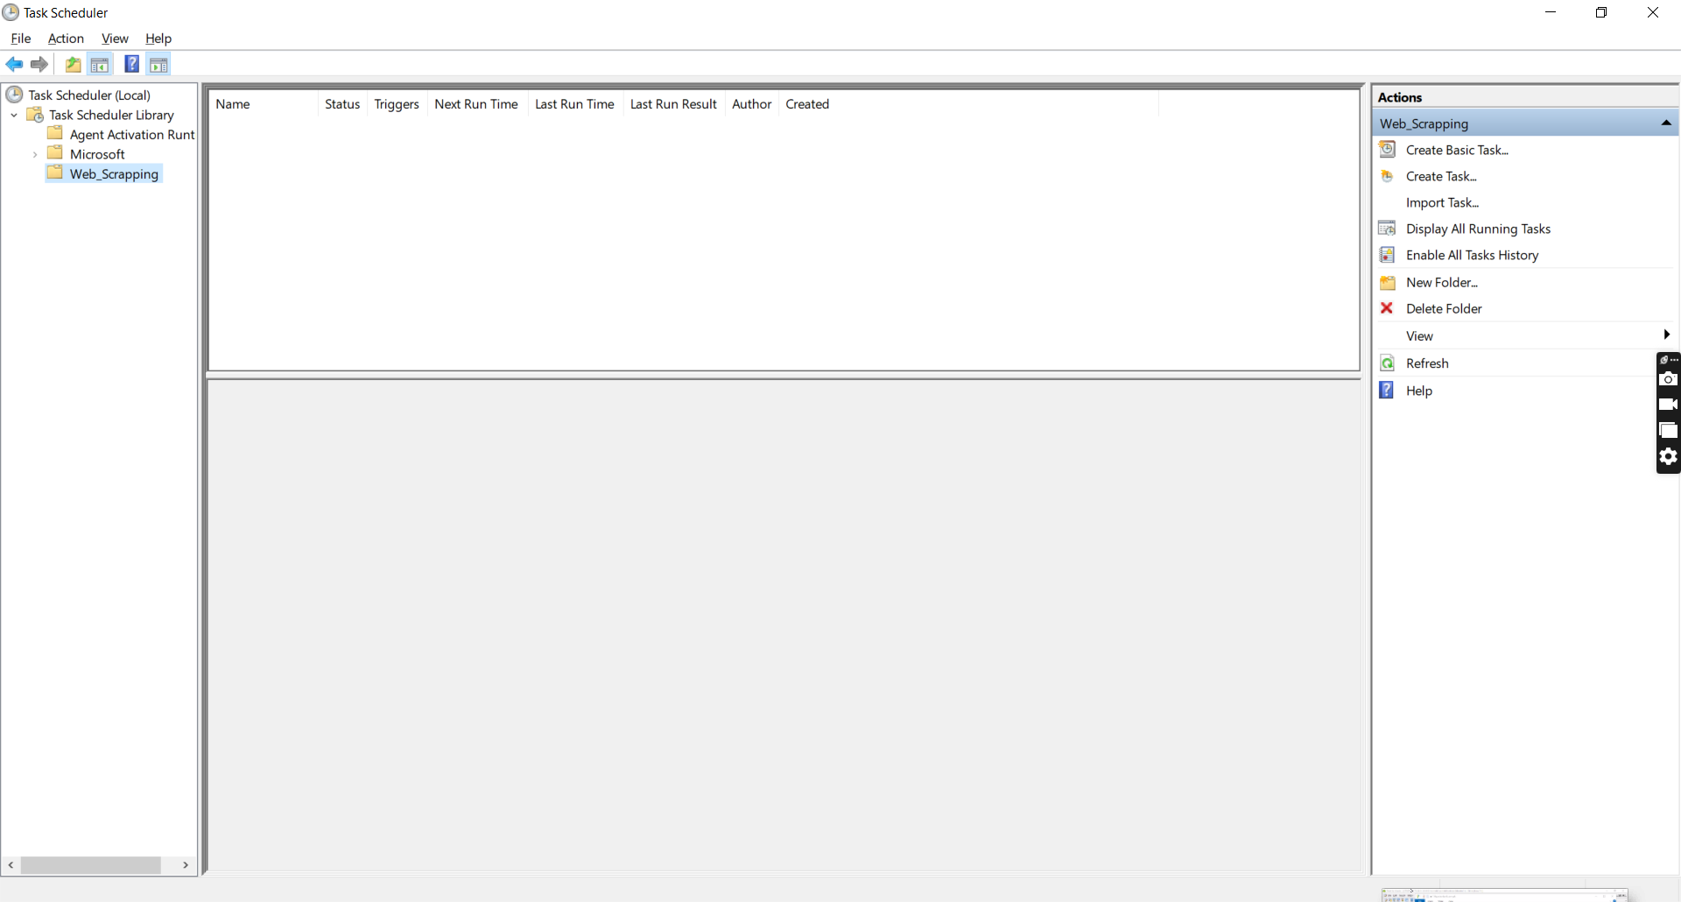

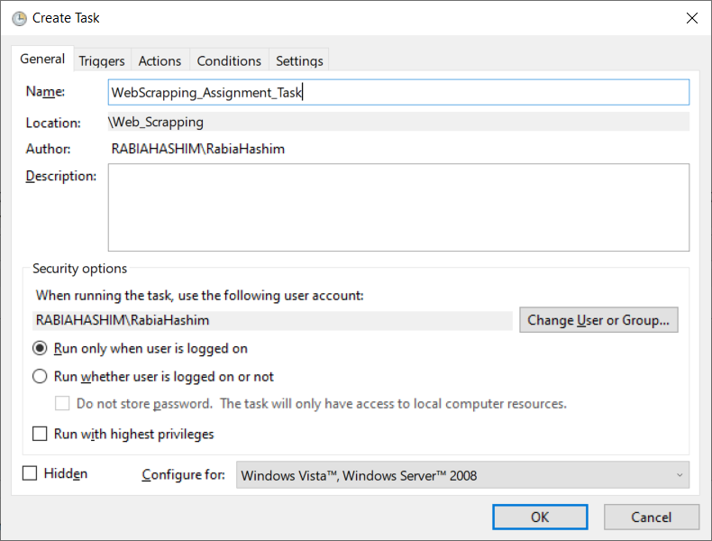Step 2: Added/Created Task on windows task scheduler.

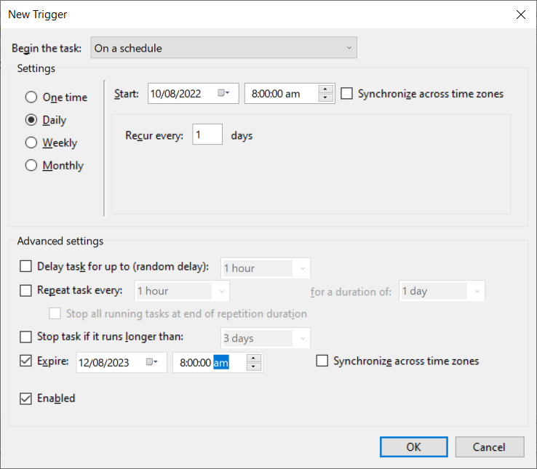Step 3: Added Trigger frequency for scheduling task

Step 4: Added run.bat script to be run on daily basis at 8:00 am

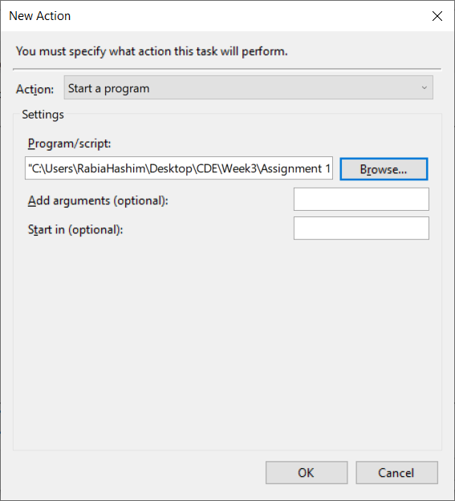

Step 5: Task is scheduled

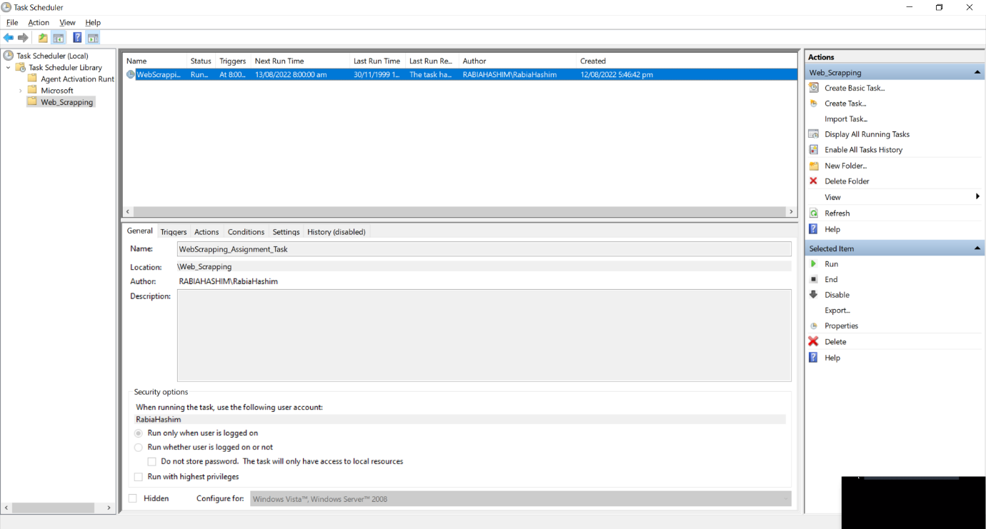

**Task 4: change cron job into human command and human to cron jobs.**

**1. 0 17 * * 0-5**

**2. 11 5 * * 5,6**

**3. every Monday midnight**

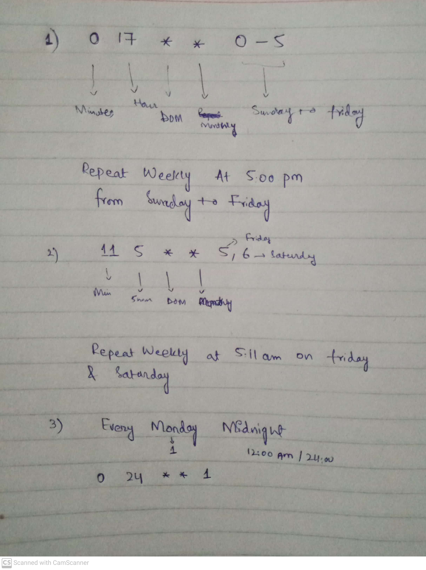

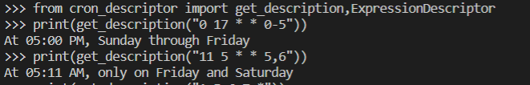**Using Python**